Event Details and Traffic Control
Please include a summary of your event

Please include Date/s and times for your event
Contact details of key personnel

Please describe the key traffic disruptions you anticipate during your event.
Please list all of the streets (inc) directions that will be impacted by your event
Will you be using Traffic control contractors? Please include details of organisation, operators and contact details.

Traffic Control Plan Site Diagram
Please attach a Traffic Control Plan Site Diagram.
You can find an example of a Traffic Control Plan Site Diagram below.

- Please describe the traffic control measures you will be implementing, and attach drawings of the layout of barriers, walkways, signs and the general arrangements to warn and guide traffic around, past or within an event site.
- Please include travel paths for vehicles including entries and exits and routes for special or heavy vehicles.
- Include traffic crossing another stream of traffic and special event clearways.
- Include pedestrian routes.
- A map naming the roads and affected areas.
- Show the direction / course / usage or the roads including any start/finish areas.
- Include a car park plan to where you suggest participants, contractors, staff and public will park.
Please describe the number of entries and exits and how they will be managed. These must be clearly marked on your traffic control plan diagram

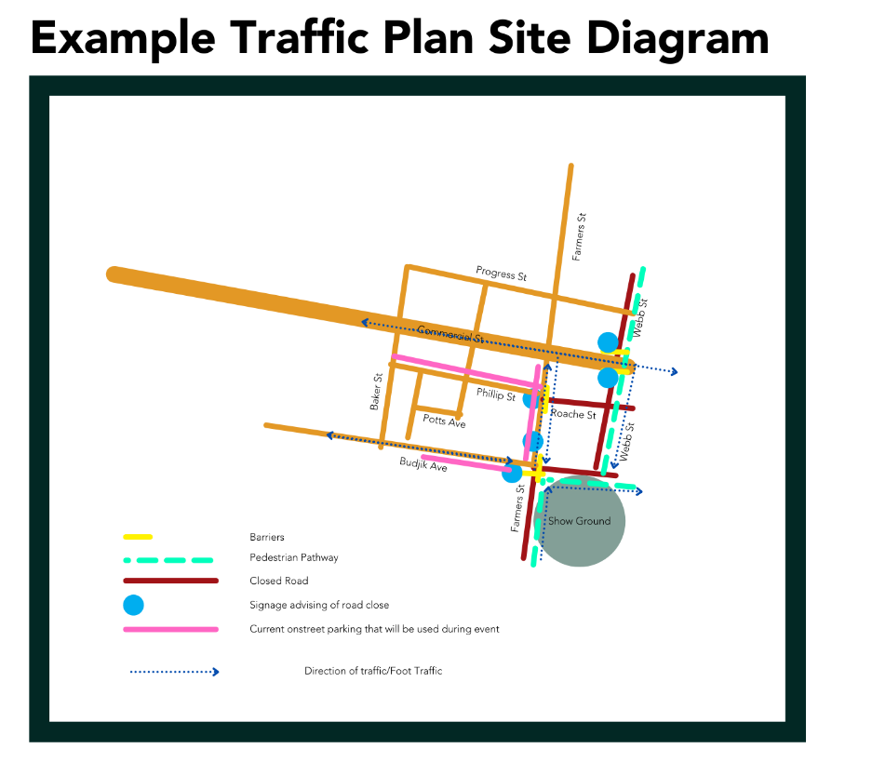
Control Measures
Please explain how you will be monitoring and controlling site access provided to delivery vehicles throughout an event
Please provide details of the parking arrangements including over-flow parking. Please include diagram/site map for parking
Please provide details of the provisions for people with disabilities e.g. ramps at entries and exits
Please detail the responsibilities of traffic controllers in the workplace
Please detail the responsibilities of people expected to interact with traffic in the workplace
Please describe how there will be communication between the traffic monitors and event management in case of an emergency, and
Please explain how to implement and monitor the effectiveness of a traffic management plan.
Risk Assessment
Attach a Risk Assessment for your traffic management and parking arrangements.

